Task 1: Execute all yaml files shown in video.
1.Apply a NoSchedule Taint to a Kubernetes Worker Node
Command : kubectl taint node k8s-worker1 special=true:NoSchedule
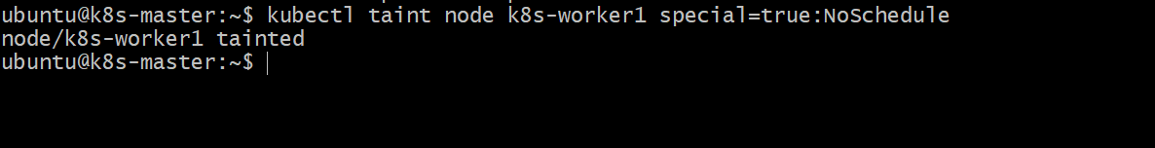
Check : description
Command : kubectl describe node k8s-worker1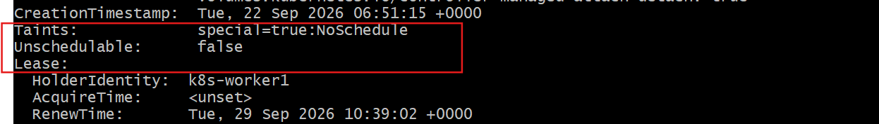
Create nano first.yaml
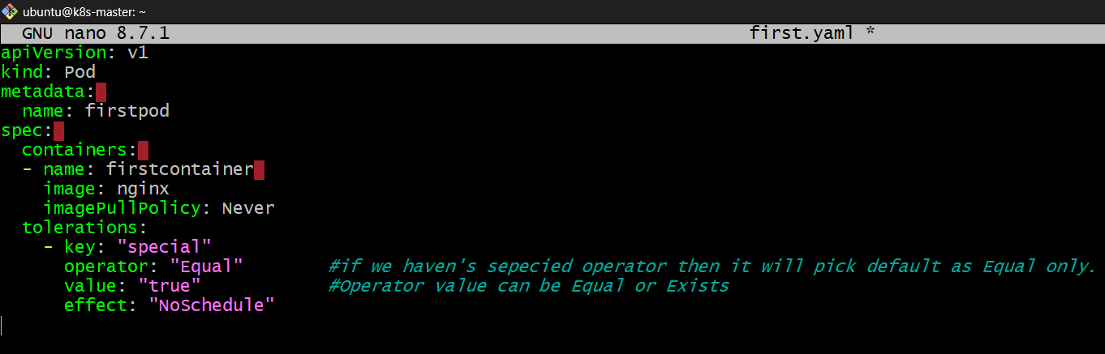
Apply
Command : kubectl apply -f first.yaml
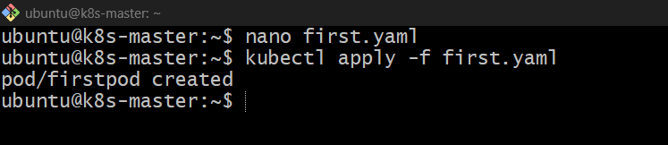

Command : kubectl get pods -o wide
Create second pods
nano first.yaml
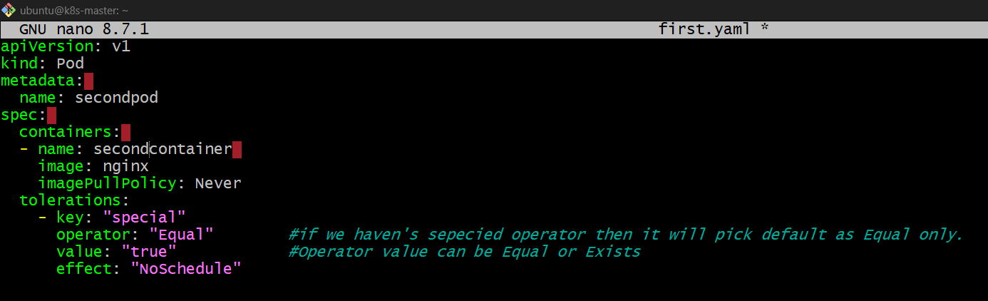
Command : kubectl apply -f first.yaml
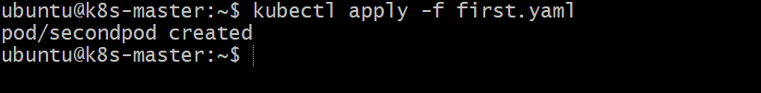
Command : kubectl get pods -o wide
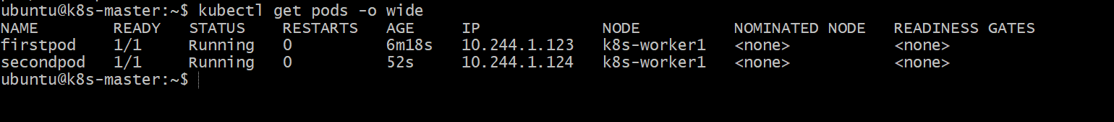

2.Noexecute
Command : kubectl taint node k8s-worker2 special=true:NoExecute 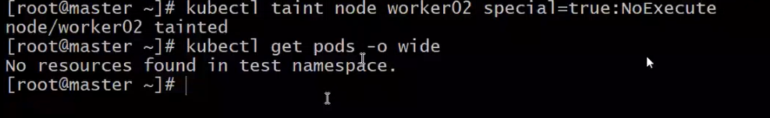
But your secondpod is probably trying to run without a matching toleration, or there is another scheduling constraint.
- First check why the Pod is Pending
There is no toleration on the pod

Command : kubectl describe pod secondpod
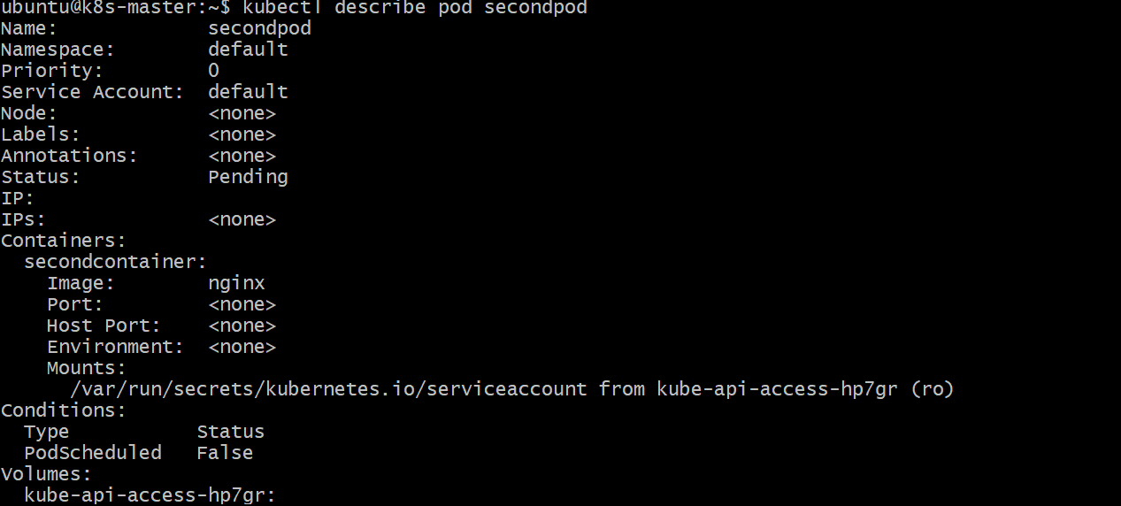

Command : kubectl get pods -o wide
Describe a Pod
Command : kubectl describe pod secondpod

Remove Taint/Untaint
Command : kubectl taint node k8s-worker2 special=true:NoExecute –
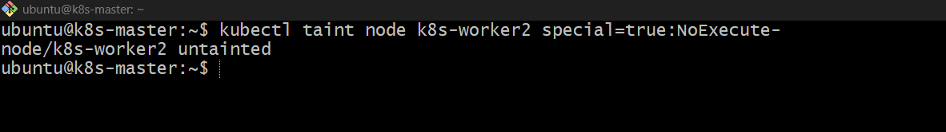
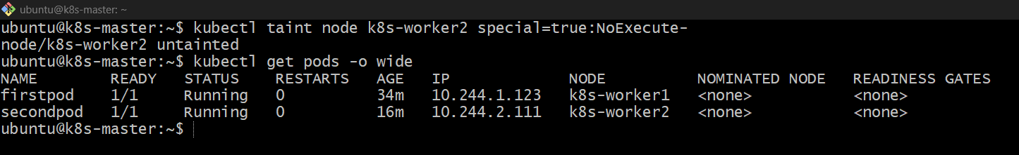

Task 2: Taint a Node and Schedule a Tolerant Pod Taint a node with special=true:NoSchedule. Create a pod with a toleration that matches the taint, allowing it to be scheduled on the tainted node.
Purpose:
To taint a Kubernetes worker node with special=true:NoSchedule and create a Pod with a matching toleration, allowing the Pod to be scheduled on the tainted node.
Step 1: Taint the Node
kubectl taint node k8s-worker1 special=true:NoSchedule
Purpose: Prevents new Pods without the matching toleration from being scheduled on k8s-worker1. 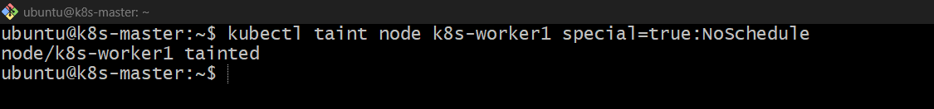
Step 2: Verify the Taint
kubectl describe node k8s-worker1 | grep Taints
Expected:
Taints: special=true:NoSchedule 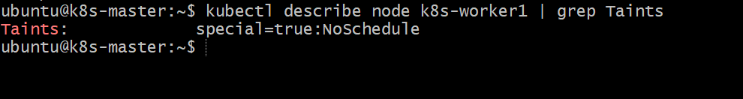
Step 3: Create the Pod YAML
nano tolerant-pod.yaml
Add:
apiVersion: v1
kind: Pod
metadata:
name: tolerant-pod
spec:
tolerations:
- key: "special"
operator: "Equal"
value: "true"
effect: "NoSchedule"

containers:
- name: nginx
image: nginx 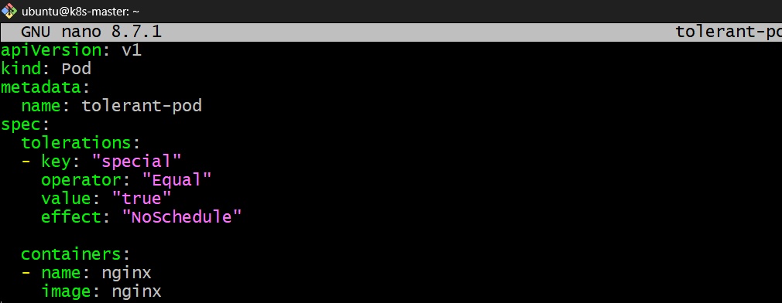
Step 4: Create the Pod
kubectl apply -f tolerant-pod.yaml 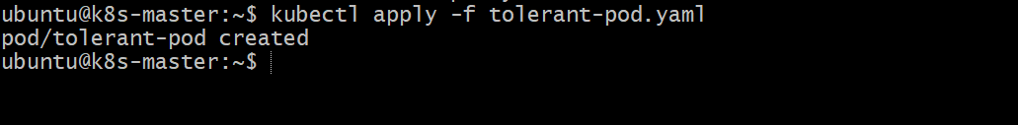
Step 5: Verify the Pod
kubectl get pod tolerant-pod -o wide
Expected
NAME READY STATUS NODE
tolerant-pod 1/1 Running k8s-worker1
Key Point
Taint → Keeps Pods away
Toleration → Allows the Pod to run
Note: A toleration makes the Pod eligible to run on the tainted node; it does not by itself guarantee that Kubernetes will choose that node.

Task 3: Use NodeSelector to Schedule a Pod on a Specific Node Label a node with env=dev. Create a pod with a nodeSelector that schedules it only on the node labeled env=dev.
Purpose
To label a worker node with env=dev and use NodeSelector to ensure the Pod is scheduled only on a node having that label.
Step 1: Label the Node
kubectl label node k8s-worker1 env=dev
Purpose: Adds the label env=dev to k8s-worker1. 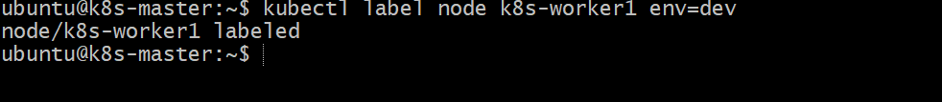
Step 2: Verify the Label
kubectl get nodes --show-labels
You should see:
k8s-worker1 ... env=dev 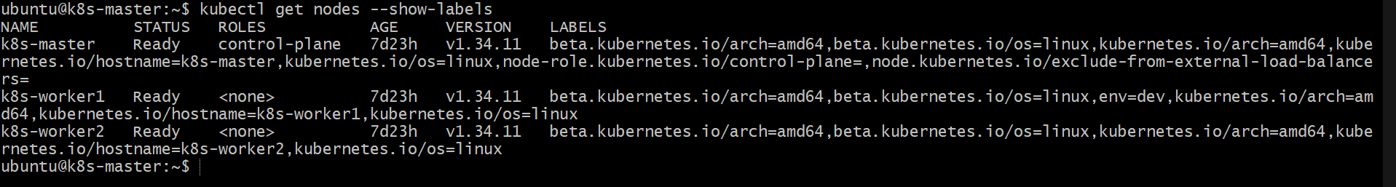
Step 3: Create the Pod YAML
nano dev-pod.yaml
Add:
apiVersion: v1
kind: Pod
metadata:
name: dev-pod
spec:
nodeSelector:
env: dev

containers:
- name: nginx
image: nginx 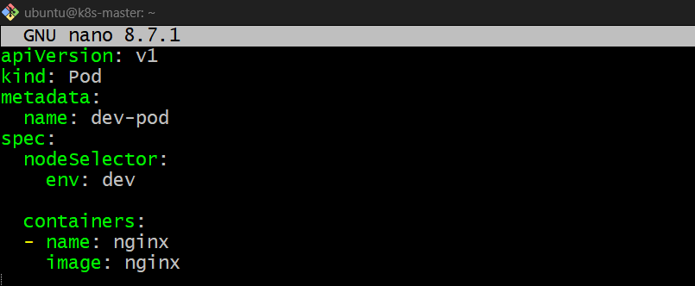
Step 4: Create the Pod
kubectl apply -f dev-pod.yaml
Purpose: Creates the Pod with a scheduling requirement for env=dev. 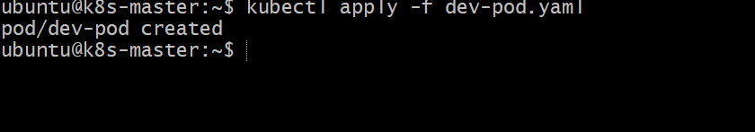
Step 5: Verify Pod Placement
kubectl get pod dev-pod -o wide
Expected:
NAME READY STATUS NODE
dev-pod 1/1 Running k8s-worker1 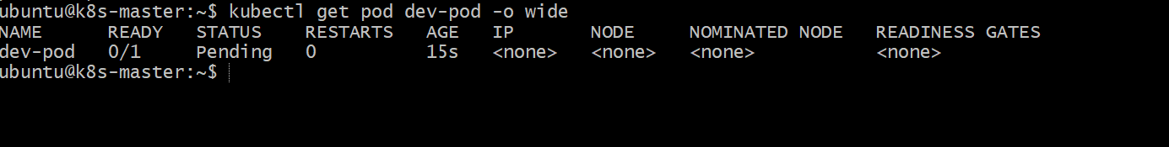
Step 6: Verify the Node Label
kubectl get node k8s-worker1 --show-labels

Key Point
Node Label:
k8s-worker1 → env=dev
↓
nodeSelector:
env: dev
↓
Pod
↓
Scheduled only on a node with env=dev
Interview point: nodeSelector is a simple and strict way to constrain a Pod to nodes with a specific label.

Task 4: Use Node Affinity with Soft Scheduling Label a node with env=test. Create a pod with PreferredDuringSchedulingIgnoredDuringExecution node affinity, preferring to schedule it on a node labeled env=test. Remove the label and verify the pod continues to run.
Purpose
To use soft node affinity so Kubernetes prefers a node labeled env=test, but does not require it. After removing the label, the existing Pod should continue running.

Step 1: Label the Node
Use k8s-worker2:
kubectl label node k8s-worker2 env=test
Purpose: Adds the env=test label to k8s-worker2. 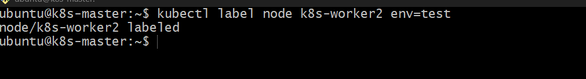
Step 2: Verify the Label
kubectl get node k8s-worker2 --show-labels
You should see:
env=test

Step 3: Create the Pod YAML
nano test-affinity-pod.yaml
Add:
apiVersion: v1
kind: Pod
metadata:
name: test-affinity-pod
spec:
affinity:
nodeAffinity:
preferredDuringSchedulingIgnoredDuringExecution:
- weight: 100
preference:
matchExpressions:
- key: env
operator: In
values:
- test

containers:
- name: nginx
image: nginx 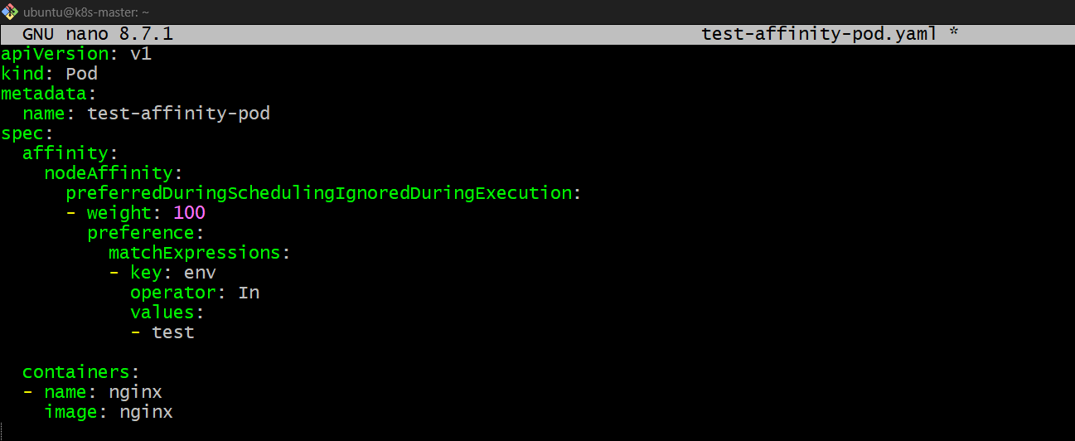
What does this mean?
preferredDuringSchedulingIgnoredDuringExecution
Means:
"During scheduling, prefer a node with env=test, but don't make it mandatory."
weight: 100 gives this preference the highest possible weight.

Step 4: Create the Pod
kubectl apply -f test-affinity-pod.yaml 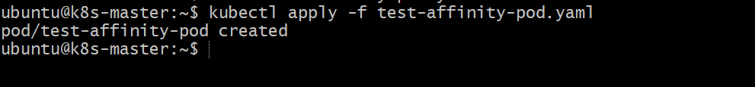
Step 5: Verify Pod Placement
kubectl get pod test-affinity-pod -o wide
Expected:
NAME READY STATUS NODE
test-affinity-pod 1/1 Running k8s-worker2
Because k8s-worker2 has:
env=test
Kubernetes prefers it. 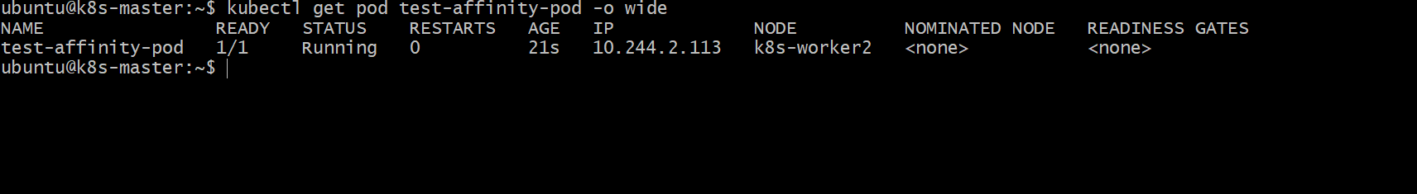

Step 6: Remove the Label
kubectl label node k8s-worker2 env-
Purpose: Removes the env label from k8s-worker2. 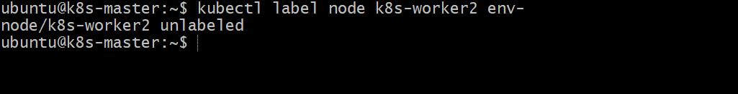Verify:
kubectl get node k8s-worker2 --show-labels

Step 7: Check the Pod
kubectl get pod test-affinity-pod -o wide
The Pod should continue running.
NAME READY STATUS NODE
test-affinity-pod 1/1 Running k8s-worker2 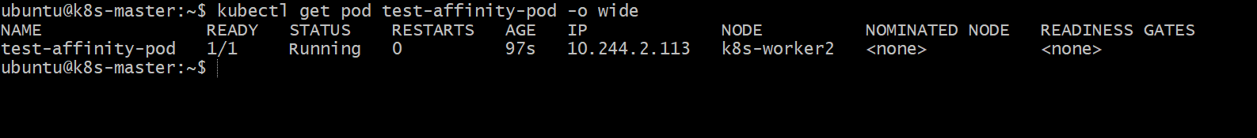
Why does it continue running?
Because:
PreferredDuringSchedulingIgnoredDuringExecution
has two important parts:
PreferredDuringScheduling
→ Kubernetes prefers env=test during scheduling.
IgnoredDuringExecution
→ If the env=test label is removed later, Kubernetes does not evict the running Pod.
Key Difference
Preferred = Soft rule
Required = Hard rule
So for this task:
env=test exists
↓
Pod prefers k8s-worker2
↓
Pod is Running
↓
Remove env=test
↓
Pod continues Running

Task 5: Implement Node Affinity with Hard Scheduling Create a pod with RequiredDuringSchedulingIgnoredDuringExecution node affinity, ensuring it will only be scheduled on a node labeled env=prod. Verify the pod cannot be scheduled if no node has the env=prod label.

Purpose
To use hard node affinity so that a Pod can be scheduled only on a node labeled env=prod.
If no node has the env=prod label, the Pod will remain Pending.

Step 1: Make sure no node has env=prod
Check:
kubectl get nodes --show-labels
If you see env=prod on any node, remove it:
kubectl label node <node-name> env- 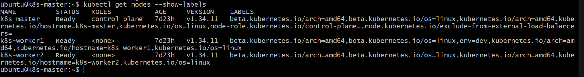

Step 2: Create the Pod YAML
nano prod-affinity-pod.yaml
Add:
apiVersion: v1
kind: Pod
metadata:
name: prod-affinity-pod
spec:
affinity:
nodeAffinity:
requiredDuringSchedulingIgnoredDuringExecution:
- nodeSelectorTerms:
- matchExpressions:
- key: env
operator: In
values:
- prod

containers:
- name: nginx
image: nginx
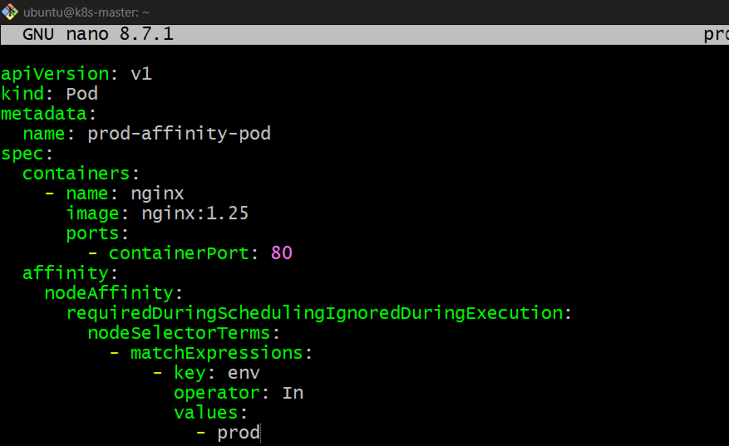
What does this mean?
requiredDuringSchedulingIgnoredDuringExecution
Means:
The Pod must be scheduled on a node with env=prod.
It is a hard scheduling rule.

Step 3: Create the Pod
kubectl apply -f prod-affinity-pod.yaml
Purpose: Creates the Pod with a mandatory env=prod node requirement.

Step 4: Check the Pod
kubectl get pod prod-affinity-pod -o wide
Because there is no env=prod node, you should see:
NAME READY STATUS NODE
prod-affinity-pod 0/1 Pending <none>

Step 5: Find the Reason
kubectl describe pod prod-affinity-pod
Look at the Events section.
You should see a scheduling failure indicating that the available nodes don't satisfy the Pod's node affinity requirement. 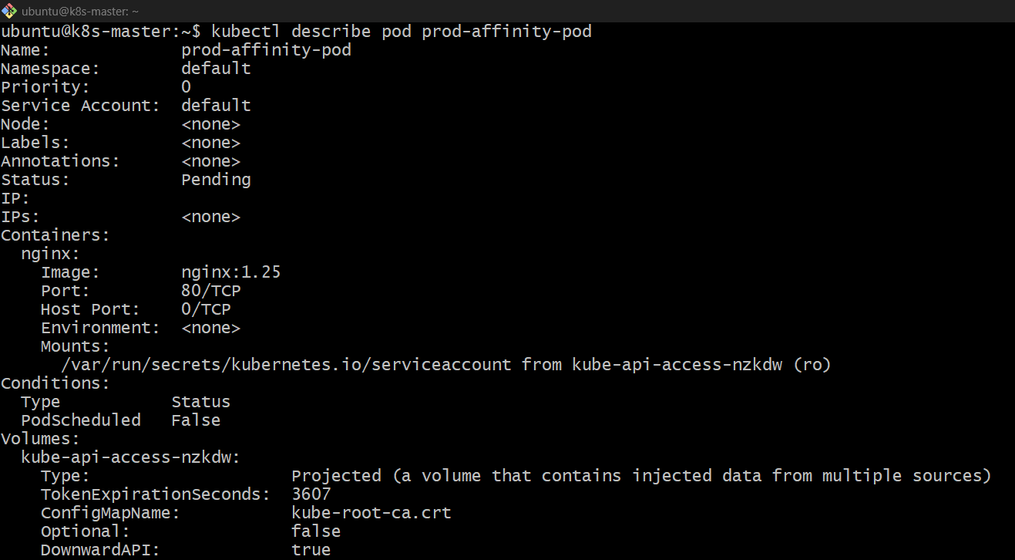

Step 6: Label a Node as env=prod
For example:
kubectl label node k8s-worker1 env=prod
Purpose: Adds the required label to k8s-worker1.
Verify:
kubectl get nodes --show-labels

Step 7: Check the Pod Again
kubectl get pod prod-affinity-pod -o wide
Now Kubernetes can schedule it:
NAME READY STATUS NODE
prod-affinity-pod 1/1 Running k8s-worker1
How the process works
Pod requires:
env=prod
↓
Scheduler checks nodes
↓
No env=prod
↓
Pod = Pending
↓
Add env=prod to k8s-worker1
↓
Scheduler finds matching node
↓
Pod = Running

Task 6: Taint a Node and Use NoExecute with Toleration Seconds Taint a node with special=true:NoExecute. Create a pod with a tolerationSeconds field (e.g., 60 seconds) and observe it gets evicted after 60 seconds on the tainted node.
Purpose
To understand how the NoExecute taint works with tolerationSeconds. The Pod will be allowed to stay on the tainted node for 60 seconds, after which Kubernetes can evict it.

Step 1: Taint the Node
Use k8s-worker2:
kubectl taint node k8s-worker2 special=true:NoExecute
Purpose: Applies a NoExecute taint to k8s-worker2. Verify:
kubectl describe node k8s-worker2 | grep Taints
Expected:
Taints: special=true:NoExecute 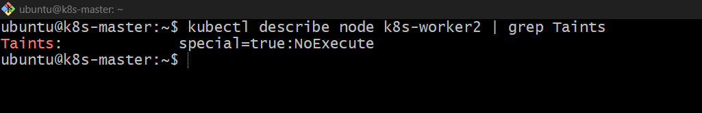

Step 2: Create the Pod YAML
nano temporary-pod.yaml
Add:
apiVersion: v1
kind: Pod
metadata:
name: temporary-pod
spec:
tolerations:
- key: "special"
operator: "Equal"
value: "true"
effect: "NoExecute"
tolerationSeconds: 60

containers:
- name: nginx
image: nginx
Important
tolerationSeconds: 60 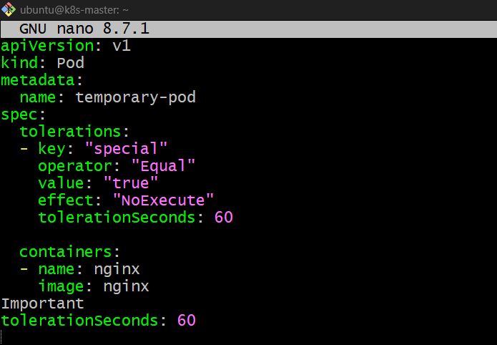
means:
The Pod can tolerate the special=true:NoExecute taint for 60 seconds.

Step 3: Create the Pod
kubectl apply -f temporary-pod.yaml
Purpose: Creates a Pod with a 60-second toleration. 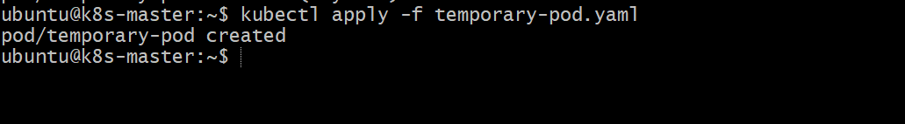

Step 4: Check the Pod
kubectl get pod temporary-pod -o wide
You may see:
NAME READY STATUS NODE
temporary-pod 1/1 Running k8s-worker2
The Pod is allowed to run on the tainted node because it has a matching toleration. 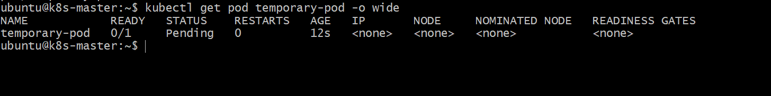

Step 5: Observe the Pod
Watch the Pod:
kubectl get pod temporary-pod -o wide -w
The Pod may initially show:
temporary-pod 1/1 Running k8s-worker2
After approximately 60 seconds, Kubernetes can evict the Pod because its toleration period has expired.
Press:
Ctrl + C
to stop watching.

Step 6: Check the Pod
kubectl get pod temporary-pod -o wide
You may see the Pod disappear or enter a terminating/evicted state depending on timing.
Check events:
kubectl describe pod temporary-pod 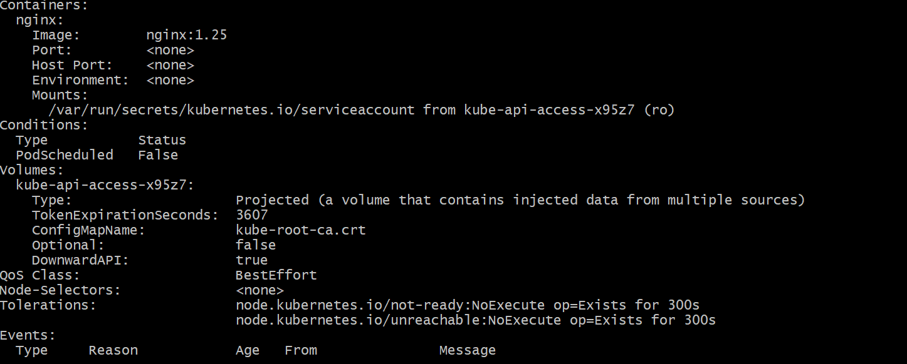

Important: Why NoExecute?
There are three important taint effects:
Effect | Behavior
NoSchedule | New non-tolerating Pods are not scheduled
PreferNoSchedule | Kubernetes tries to avoid scheduling them
NoExecute | New Pods are blocked and existing non-tolerating Pods can be evicted
With:
effect: NoExecute
tolerationSeconds: 60
the behavior is:
Node
↓
special=true:NoExecute
↓
Pod has matching toleration
↓
Pod allowed to stay
↓
60 seconds
↓
Toleration expires
↓
Pod can be evicted
Remove the taint after the exercise
kubectl taint node k8s-worker2 special=true:NoExecute-
Verify:
kubectl describe node k8s-worker2 | grep Taints
Expected:
Taints: <none>
Key interview point: tolerationSeconds is applicable to NoExecute tolerations and specifies how long a Pod can remain bound to a node after the taint is applied.

